EXNO: 2
Analysis of SWR (Standing Wave Ratio) Transmission Lines by varying a) load impedance b) characteristic impedance.
TEST CASE 1
Analyze the SWR of a transmission line for a fixed characteristic impedance (Zo) of 50ohms, as the load impedance (ZL) is varied across 650 ohms to 850 ohms. Verify how theSWR changes with each value ofZL. When ZL=Z0, the SWR should equal 1 (indicating no reflection).
PROGRAM
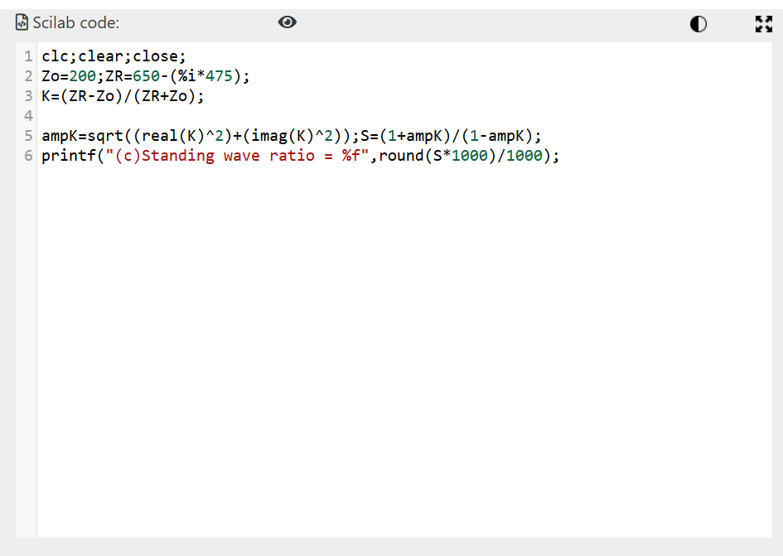
OUTPUT: 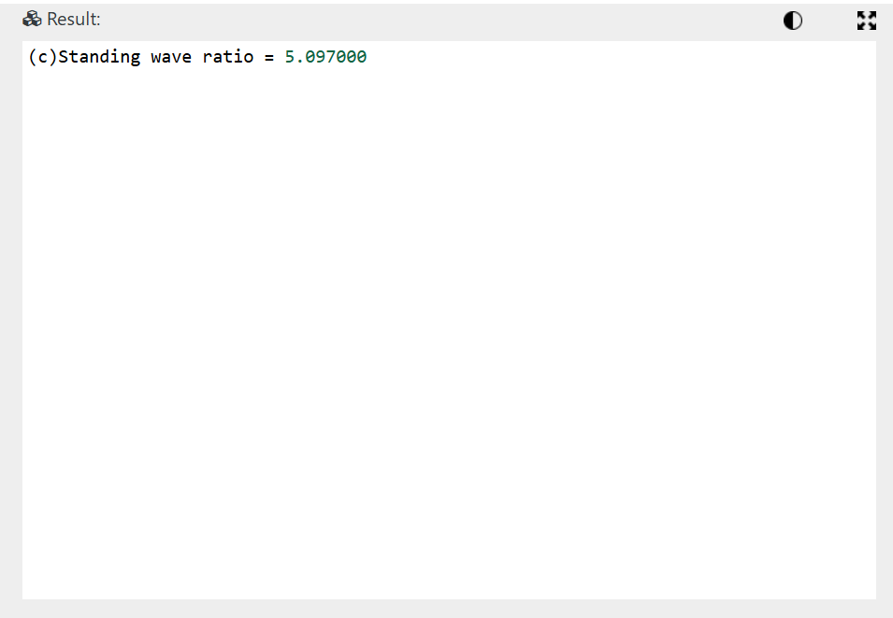
Test Case 2:
Analyze the SWR for a fixed load impedance (ZL) of 50 ohms while varying the
characteristic impedance (Z0) of the transmission line to 250 ohms to 400 ohms. Verify how the SWR changes with each value Z0 including Z0=ZL.
PROGRAM
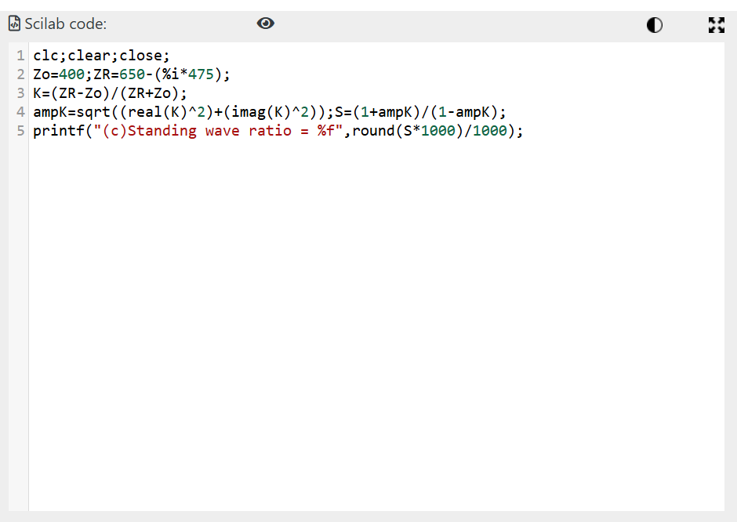
OUTPUT 